|  |  |  |  |  |  |
| --- | --- | --- | --- | --- | --- |
| **Module No:** | 1 | **IU No:** | 3 | **Exercise No.** | 3 |

**Name : Ida Bagus Ketut Yoghantara**

|  |  |
| --- | --- |
| **Lab Assessment Statement** | **Assignment 3 – Implement O Auth Integration for SignUp**  **Referring to Assignment-1's Project Scenario,**  The scope of this assignment is to implement O Auth Integration for SignUp using Facebook for ‘XYZ Cars Pte Ltd’.  These are the steps provided to build an API.   1. Create developers Account on Facebook 2. Create New Application for using social integration. 3. Implement Social login using Facebook in XYZ cars Portal. 4. Use created App Id and App Secret in Application. 5. Login using Facebook.   **Provide the source code of developed application.**  **Provide screen capture of final result pages for API testing.** |
| **Technical Environment** | - Spring Boot, Facebook API Integration |
| **Guidelines** | - |
| **Duration** | 120 mins |

1. Create developers Account on Facebook
2. Create New Application for using social integration.

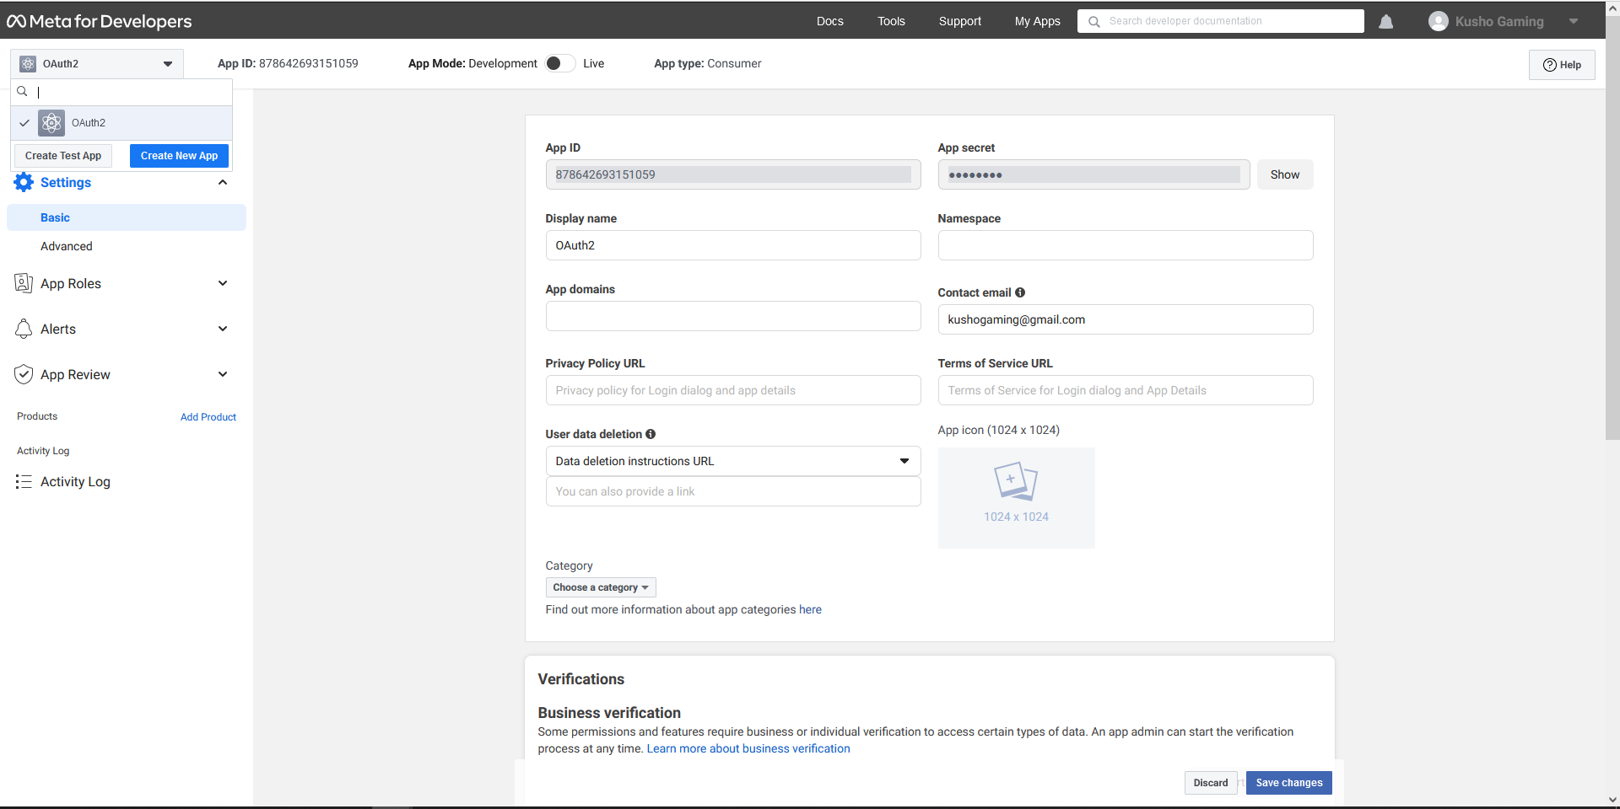

1. Implement Social login using Facebook in XYZ cars Portal.

**Because the picture take a lot of memory and I can’t submit my assignment so I have attached the full code of the implementation for spring social login with spring security and OAuth2**

1. Use created App Id and App Secret in Application.

**Application.yml**

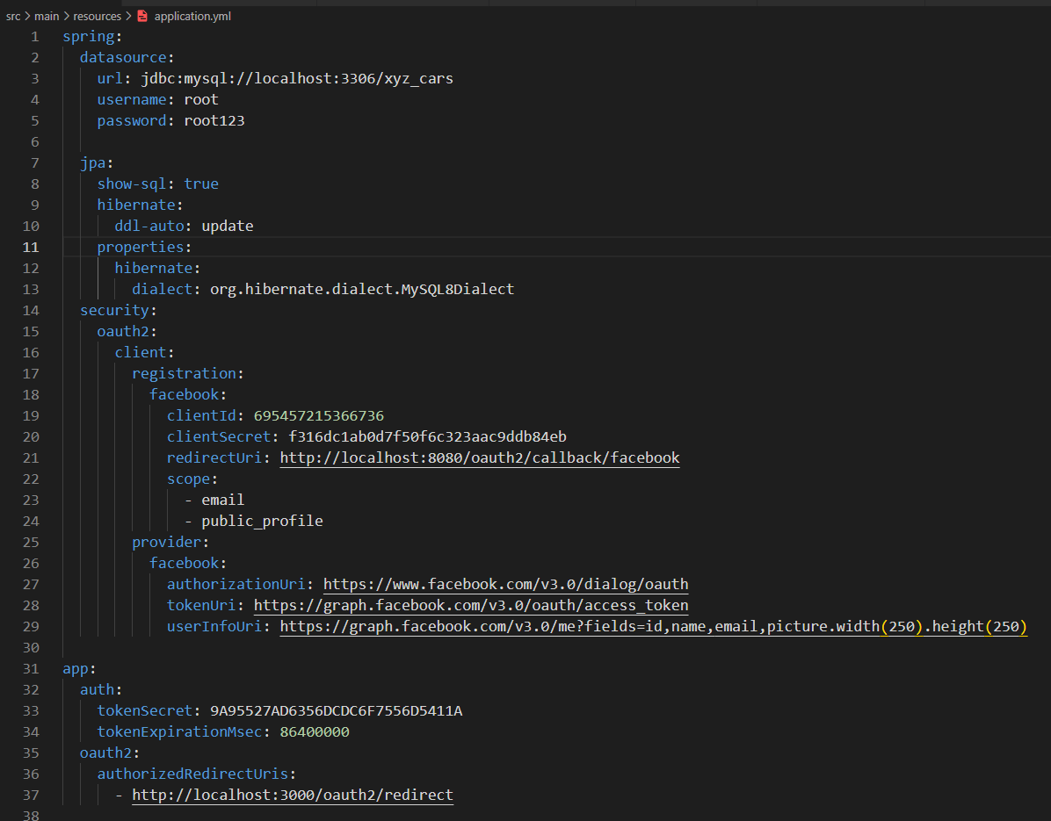

1. Login using Facebook.

**Login Page**

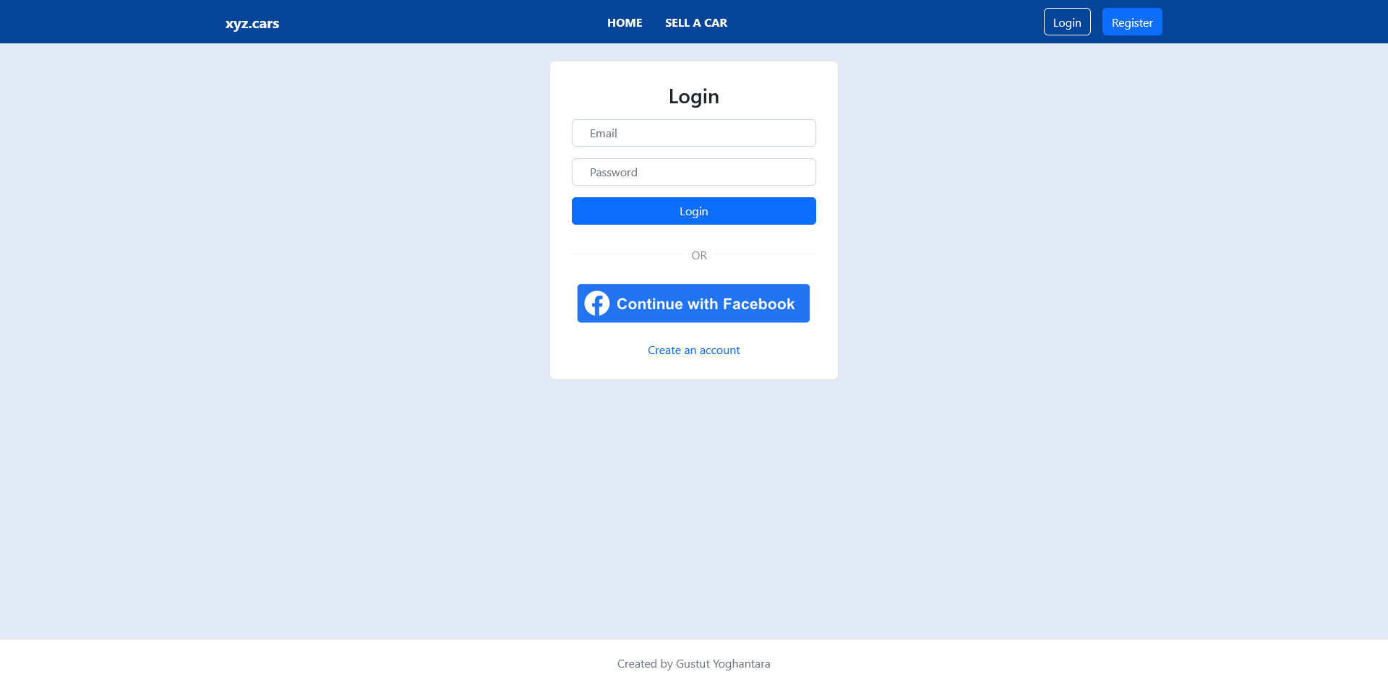

**Facebook Login**

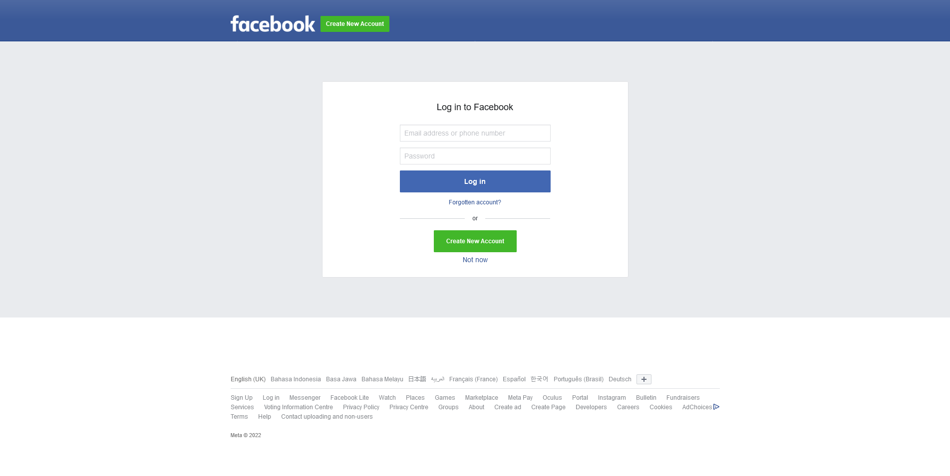

**Logged in with Facebook account**

